Annual Report for Social Action Committee - 2016 - 2017

Committee Chair Linda McLeod – 2nd year - resigning
Committee Members
Note: The Social Action Committee is not exclusive. Throughout the year various UUCC members and friends will attend our meetings depending on the issues we are addressing. There is a core group that comes regularly but we are always happy to see new faces and welcome those who come to help with a particular event. The core group is:
Laura Hartwig, Tom Clements, Tom Howell, Kevin McKinney, Connie Quirk, Carita Barr, Stephanie Palmer-Smith, Grant Seuser, Jeanette Walton, Sej Harman, Bonnie Stronach, Ceren Farr, Emilio Perez-Jorge, Cheryl Soehl, Karen Brown, Anne Mellen, Bob Whitaker, Linda Brennison, Marlene Mackey.

Major accomplishments this year

- SAC Webpage Development has been very exciting this year. Lis Turner has been a tremendous help to us in building a webpage and together we have developed an attractive site that shows just how active we are. We have learned how to use it for voting for Share the Plate and other uses of communication. Early in 2017 Laura Hartwig took over the posting to our webpage since Laura is a web designer herself and very knowledgeable about the use of the web. Laura is adding even more to our webpage to make it appear more eye-catching and to develop ways to encourage people to want to use it.
A Facebook page for the SAC was developed by Laura Hartwig and we use it regularly to advise of our many happenings. This along with our webpage has definitely brought us up to date technologically speaking.

- The Pride Parade, an annual event, took place on September 4, 2016, and was a huge success with our largest turnout from UUCC ever. We had 50 members and friends on our float or proudly walking with us the entire parade route. We had a beautiful float decorated with banners made by our members as well as carrying our own UUCC banners. UUCC is well known in Columbia and was cheered and well recognized as we traveled the parade route. This is definitely a “must do” event for the Social Action Committee. Our new co-chairs for this event this year were new members Jeanette Walton and Grant Seuser.

- Islamophobia Workshop was offered in keeping with our refugee/immigration focus. This was organized by Grant Seuser working with Manzoor Cheema of The Center for New Community. Manzoor was excellent at educating the audience about the subject of Islamophobia and gave us a clearer understanding of Islam. We had an outstanding attendance of approximately 90 people from the church and the community.

- Rally for Democracy was held on January 21, 2017, at the Statehouse and due to the heavy rain required an additional venue of the Music Farm on Senate Street. This was a very big area wide event with about 1000 squeezing into the Music Farm and in the course of the day approximately 3000 between the two venues. We had over 30 attending from UUCC. This event was a sister event for the Women’s march on Washington DC coinciding with the inauguration of President Trump in answer to his many threats against Social Justice.

- Welcome Banner was one of our biggest challenges this year. It too was a result of our attempt to spotlight the immigration/refugee issue. We had several discussions expressing a desire to place a sign or banner of some type on our property to express that all were welcome at UUCC including immigrants and refugees. With the help of Joe Long we were able to find the sentiment that we are now using that is being displayed on many churches and even in residential yards across the nation. In January we held an open meeting for any UUCC members or friends that wanted to express an opinion on the subject and we were nearly unanimous in our agreement of the banner that now hangs on the brick wall as you enter the church. It is visible from Heyward and Woodrow to passing traffic.

- Community Conversations have continued with our first one being in January. We used this format to introduce one of our major focuses this year which is the refugee/immigration crisis. This was the second showing of this film this year featuring the story of a UU couple “Defying the Nazis: The Sharps’ War”. The film was followed by a discussion on refugees. We were pleased to have an attendance of over fifty from our church and the community. Stephanie Palmer-Smith led a very productive and stimulating discussion introducing the beginning of our emphasis on this subject.

Our next Community Conversation was a film and Q&A panel collaboration with Carolina Peace Resource Center. This was the 50th anniversary of one of MLK’s most notable speeches, “MLK: A Call to Conscience”, “Beyond Vietnam: A Time to Break Silence”. We had a very well informed panel following the film to answer the questions presented by the audience. This was a most interesting and educational event.
At this time we have no further Community Conversations planned.

- Gun Violence Issues have been addressed throughout the year on several occasions. Cheryl Soehl, Stephanie Palmer-Smith, and Sej Harman, have all been active in leading UUCC in various efforts to educate the community about gun violence and how to strengthen our gun laws. Upcoming event will be June 3rd Gun Violence Awareness Family Friendly Fest and Walk SC. We are advertising and supporting this event. We continue to support legislation to change our gun laws and trying to close the “Charleston loophole”.

- Standing on the Side of Love T-shirt Sales has been a new undertaking for the SAC and has been very successful. We ordered 35 shirts for our first order and in less than a month sold all but 7. We are now taking orders for more to fill size requirements. We make a small profit on these shirts and have a united showing at rallies and parades.

- Families Helping Families was taken on with great enthusiasm again this year. We adopted four families in need at Christmastime and UUCC filled every gift on their wish list. Bonnie Stronach, Jeanette Walton, Grant Seuser, and I worked to collect the gifts each week and Bill Dolley was kind enough to help with the big task of delivering them to the Families Helping Families warehouse.

- March on Science was held on Earth Day and was considered a great success. There were over 1000 attending this area-wide rally on the Statehouse grounds to support our environment and defend it against the many political attacks that are now taking place. UUCC had 35 people in attendance with a table of literature and our UUCC banner. We had steady traffic of interested people wanting to know about Unitarian Universalism and many new prospects wanting to visit our church. We made an impressive showing at this event. A new UUCC member, Michelle Edgar was one of the coordinators of the event and was instrumental in getting us involved. Laura Hartwig did an excellent job of communication to our members to be sure they showed up.

- Ramadan Dinner will be a new experience for UUCC being held on June 2. We will be doing this with the Atlantic Institute having an opportunity to share the Ramadan event with a group of Muslims as they celebrate this religious holiday. We will be providing the sides of salads, vegetables, and fruit for dessert and they will provide the specially butchered meat. Dr. Akif Aydin will be the speaker sharing the Muslim experience of Ramadan and a Q&A session prior to the dinner which will be after sundown.

- Know your Rights presentation is a program about rights of immigrants. It is put together by SC United with Immigrants Coalition and is made up of pro-bono lawyers and interpreters. It is designed for immigrants but we believe it would also be very educational for our members and the community. We are hoping to share this on June 28th but the date is still uncertain.

- White Supremacy Teach-in will be held on July 23rd in collaboration with Worship, DRE, and Adult RE committees. Laura Hartwig will be the new SAC chair at that time and is leading this endeavor. This will be followed on July 28th with Ty dePass of Black Lives Matter as the speaker for the Worship service. Ty will be educating the congregation on exactly what Black Lives Matter is about and clarifying many misconceptions that currently exist.
- Besides these major accomplishments we still find time to maintain our regular monthly and annual events. They include:

Seeds of Hope begins in mid-June and runs through early August. This low-income farmers market is manned each Sunday by 2 volunteers and not only does it provide income to the assigned farmer, a fresh market for our members and the community, but also an excellent opportunity for outreach to our neighbors that walk giving them a chance to know who we are. As in the past Bauer Westeren manages the scheduling of this program.

Transitions Volunteers –Serving meals to homeless one Saturday a month under the scheduling management of Bob Whitaker. Assisting in the library every Friday under the supervision of Phil Turner.

Harvest Hope – collection and delivery of groceries to local foodbank by Ceren Farr. We also take a group of volunteers to work at the foodbank once a year.

Inclement Weather Center – Maintaining collection of toiletries and magazines and other needs for this center for the homeless during winter months under direction of Tom Clements.

Share the Plate continues to be an important committee under the SAC. It was recently decided that it would be an independent committee of five, functioning with the policy and procedures that were developed last year. It will however, still be considered as part of the SAC and will report all results to them.

It is with a certain amount of sadness that this will be my last report as Chair of the Social Action Committee. I have enjoyed chairing such an active and cooperative group and very satisfied with all that they have accomplished in the last two years. I am very confident in passing my torch on to Laura Hartwig. She has already taken on the leadership role and has many excellent ideas and her skills in marketing and technology will be a great asset to us.

PICTURES OF THE SOCIAL ACTION COMMITTEE ACTIVTIES

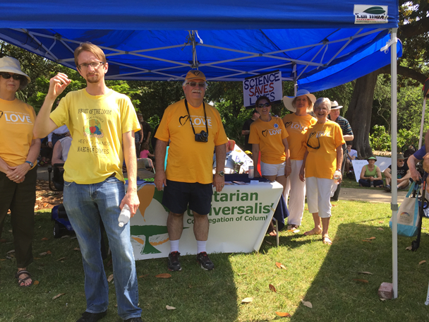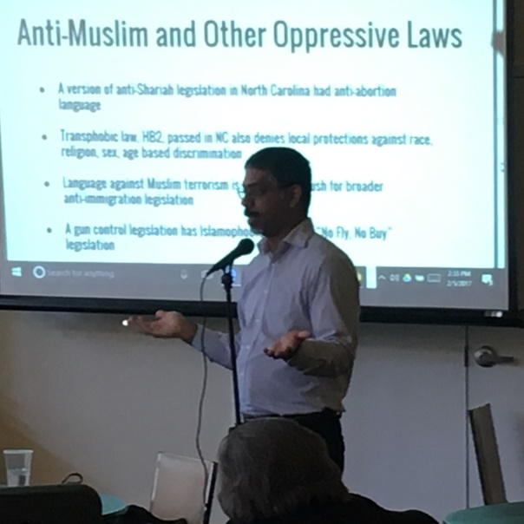

March for Science – April 2017 Islamophobia Workshop – February 2017

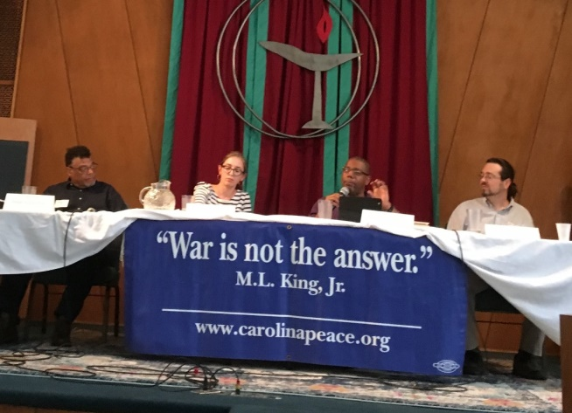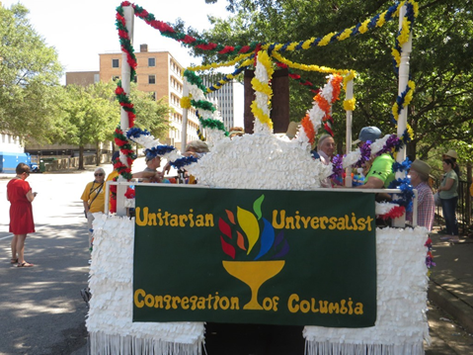
Community Conversation MLK Film – April 2017 Pride Parade – September 2016

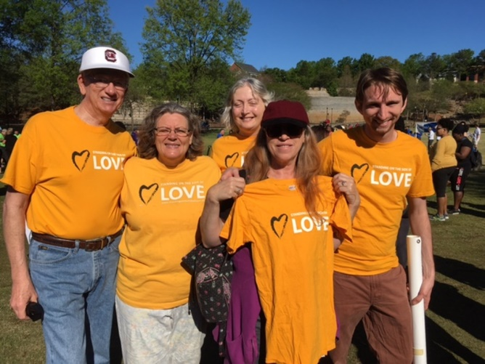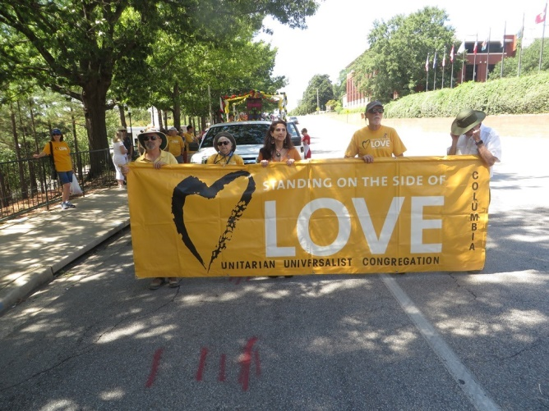

NAMI Walk – April 2017 Pride Parade – September 2016

